Assignment 4:

Invitation.html page: [https://uppity-development.000webhostapp.coms/invitation.html](https://hypereutectic-fundi.000webhostapp.com/invitation.html)

Index.html page: https://uppity-development.000webhostapp.com/index.html

Gallery.html page:  [https://uppity-development.000webhostapp.com/gallery.html](%20https://uppity-development.000webhostapp.com/gallery.html)

Registration.html page: <https://uppity-development.000webhostapp.com/registration.html>

1st Validation screen capture

Firefox Browser screen print of registration page on the left Chrome Browser on the right screen print of registration page validation

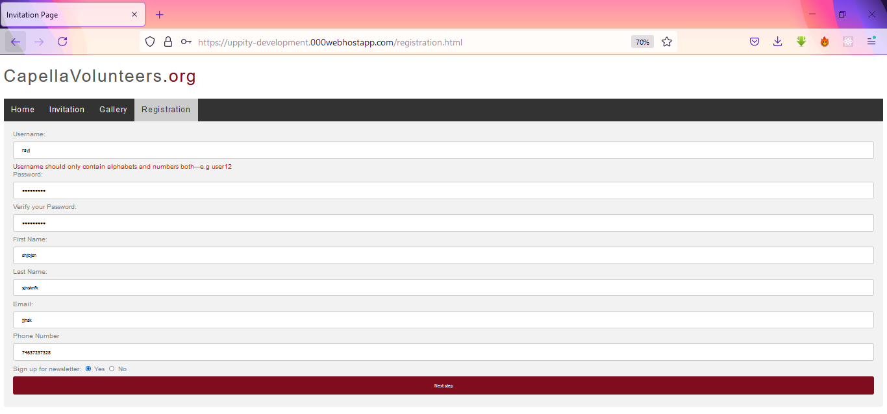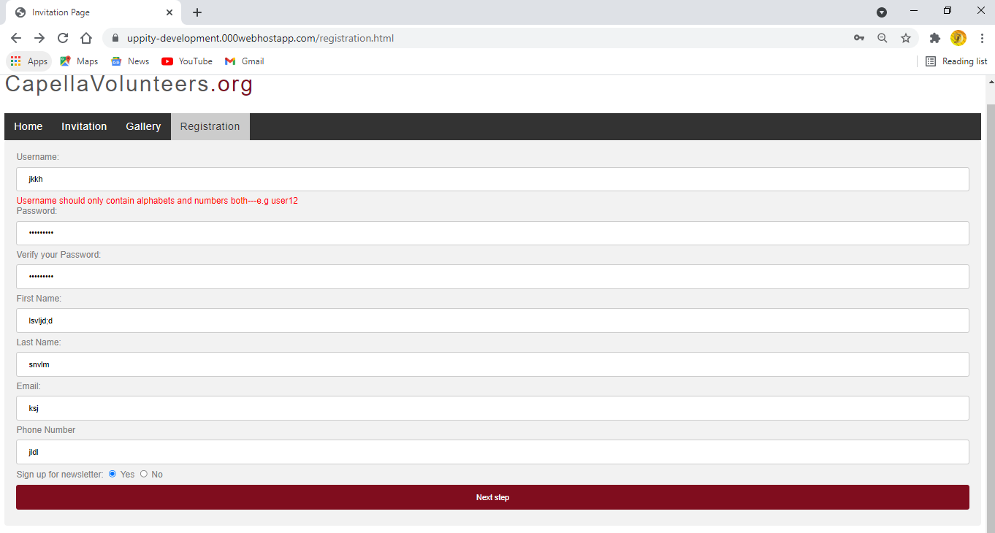

Validator screen print of the Url zero errors

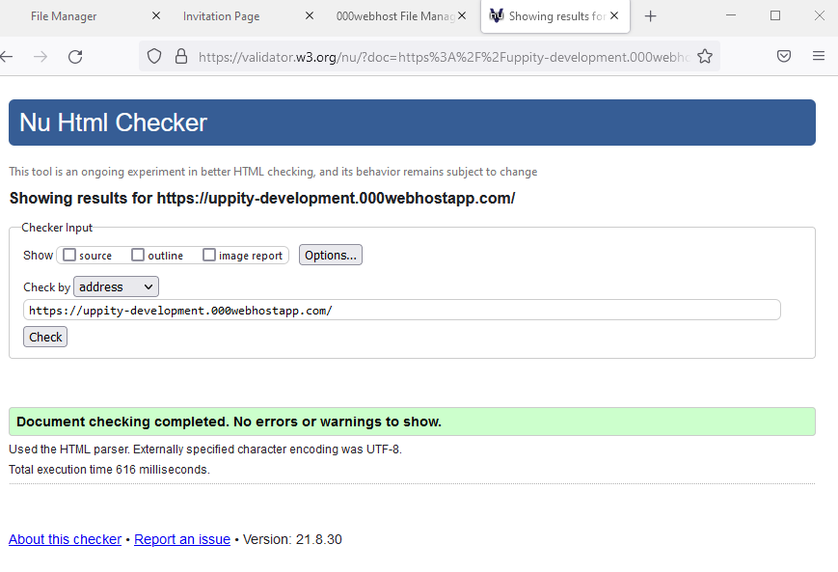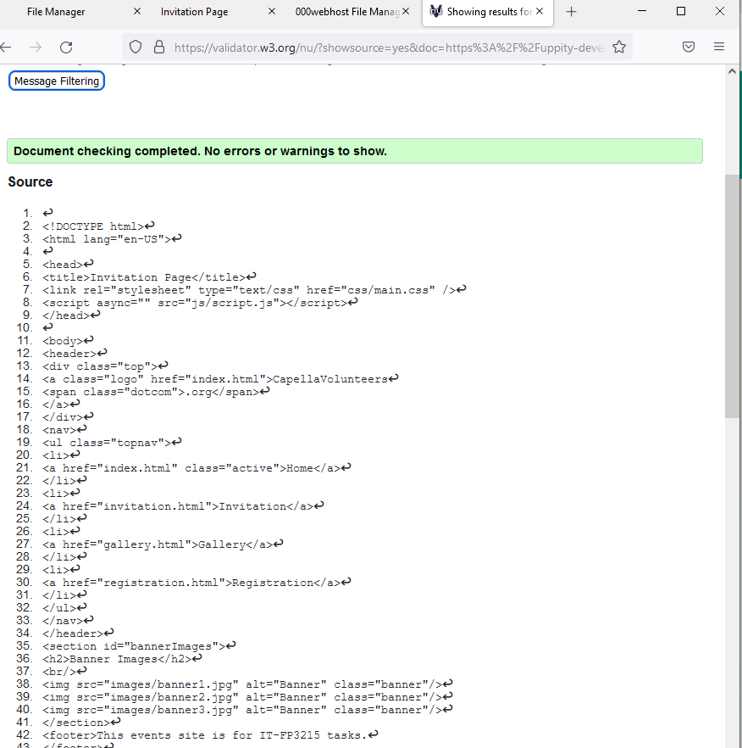

Index.html page: https://uppity-development.000webhostapp.com/index.html

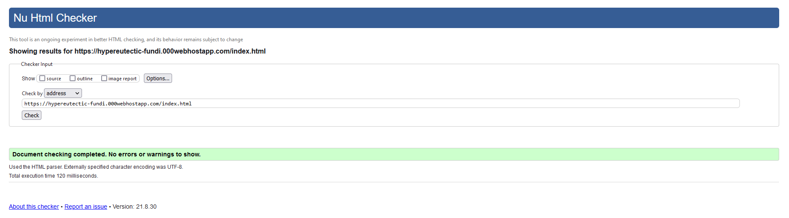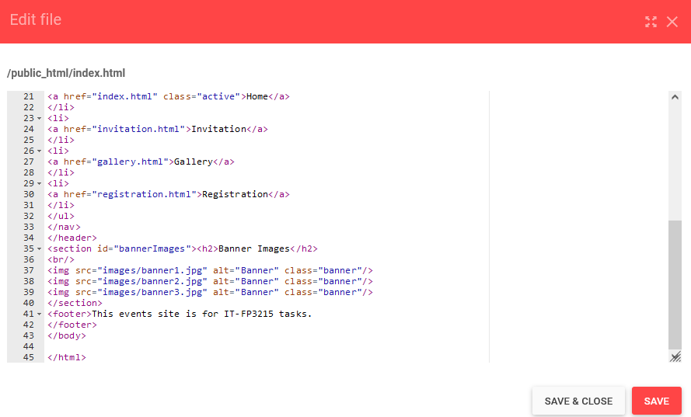

Invitation.html page: [https://uppity-development.000webhostapp.coms/invitation.html](https://hypereutectic-fundi.000webhostapp.com/invitation.html)

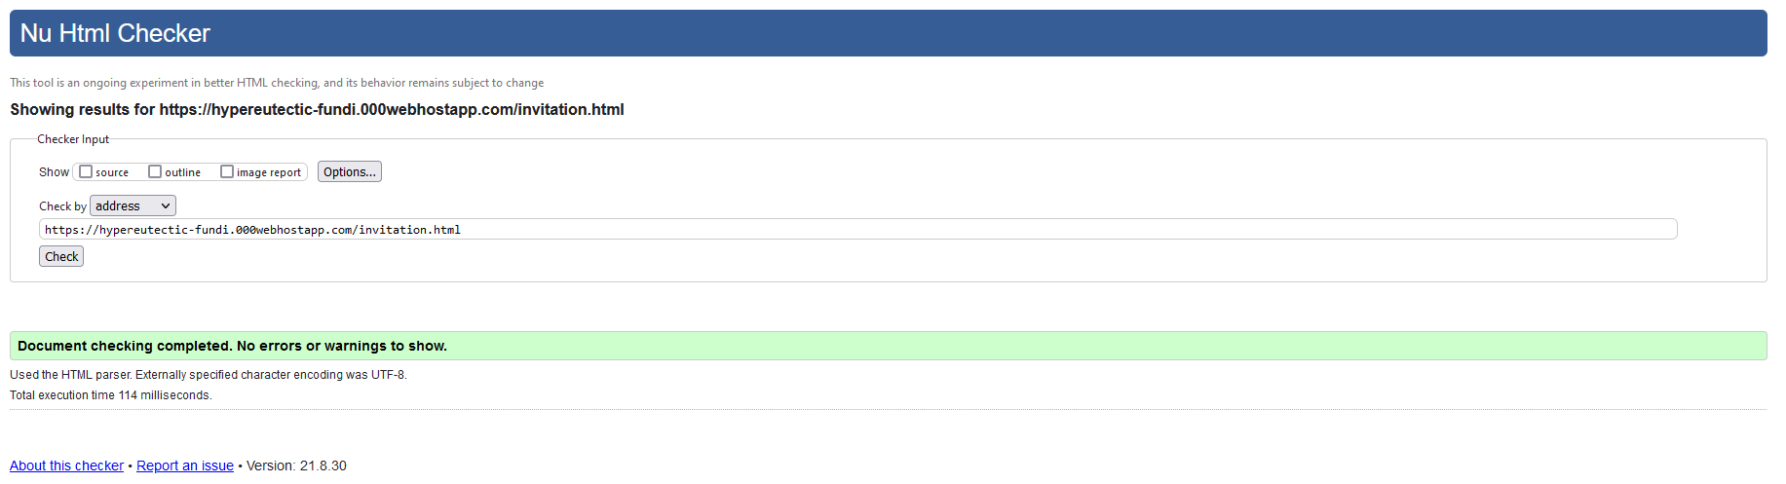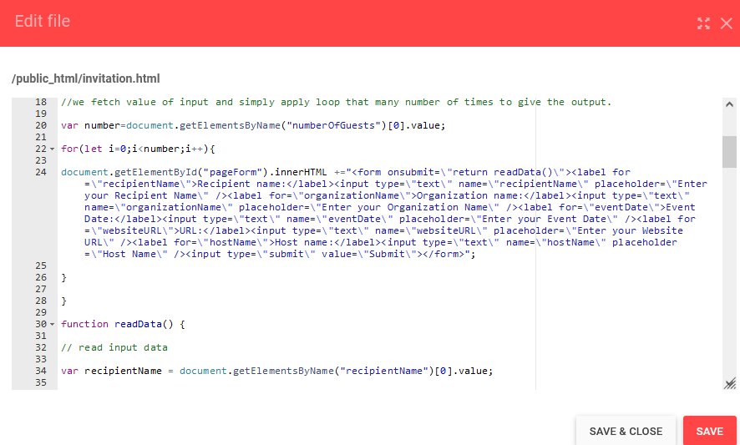

Gallery.html page:  [https://uppity-development.000webhostapp.com/gallery.html](%20https://uppity-development.000webhostapp.com/gallery.html)

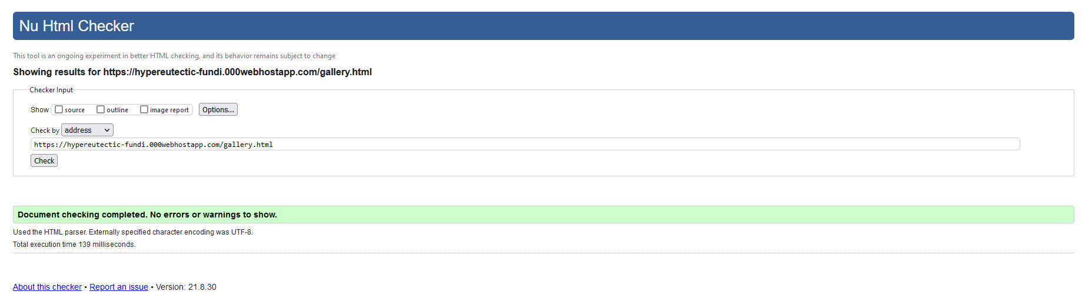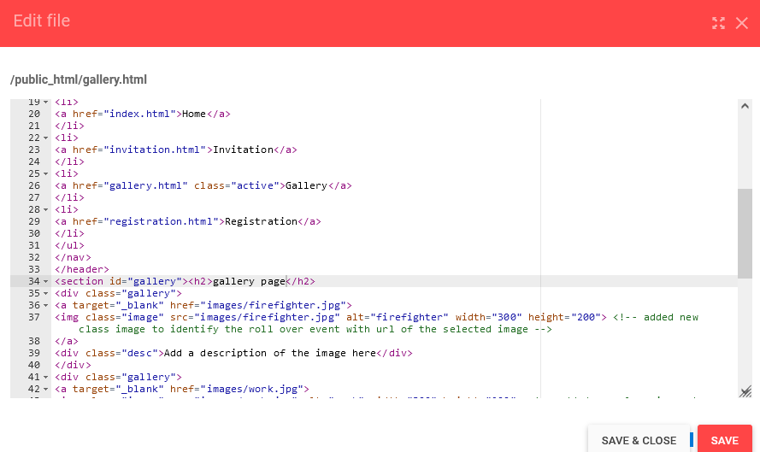

Registration.html page: <https://uppity-development.000webhostapp.com/registration.html>

